**Manage Users**

When logged in as an administrator, users of the system can be managed. More precisely, search can be done on the system in order to find one or more specific users, information about those users can be viewed and updated, and users can be deleted through this managing section.

In order to manage users, the administrator must first go to the ‘Users’tab from the home page (see Figure 1).

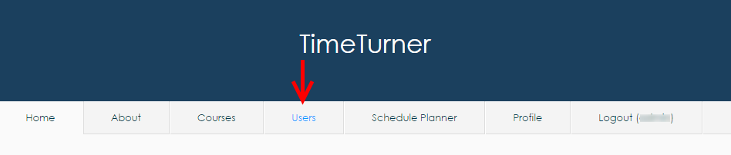

*Figure 1 ‘Users’ tab from the main menu when logged in as an Administrator*

The administrator should then see a list of users on the system, along with a list of operations that the administrator is allowed to perform. To access the user management page, the administrator must click on the ‘Manage Users’operation (see Figure 2).

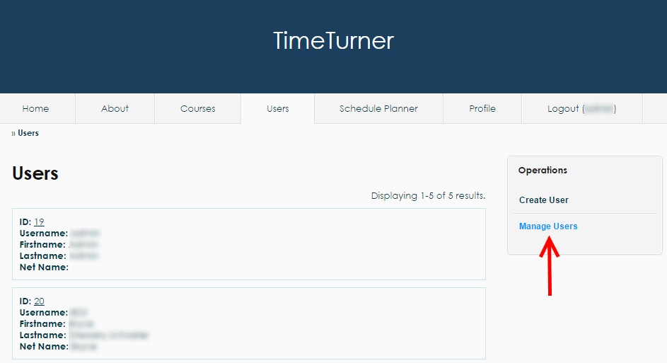

*Figure 2 ‘Manage Users’ operation found on the ‘Users’ tab*

The administrator should then land on the user management page where multiple search operations are presented with a default search result containing a list of editable users (see Figure 3).

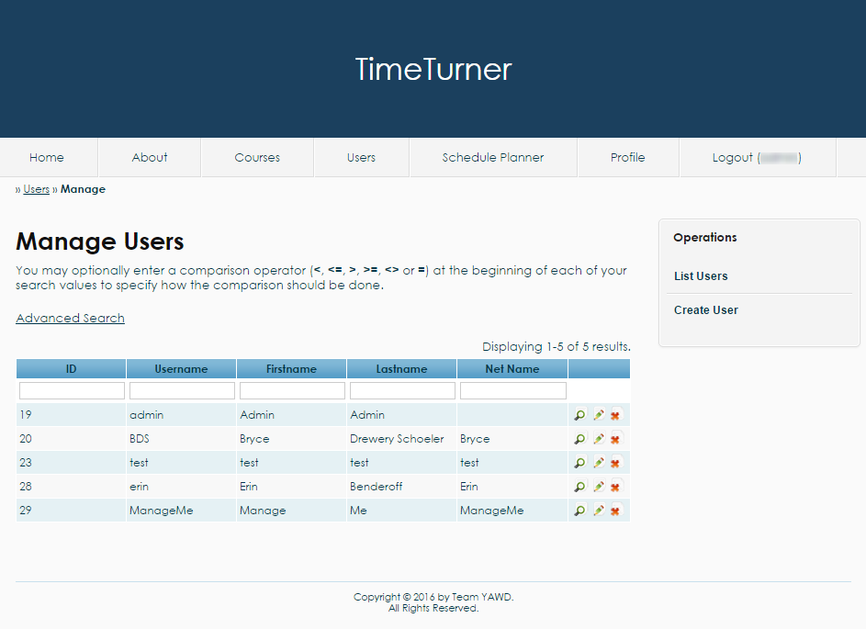

*Figure 3 User management page with a default table of users*

The following next operations will be performed from the user management page.

***Search for Users***

From the user management page, users can be found using the textboxes found on the second row of the table of users. For instance, if an administrator is looking for the user whose ID is 29, the ID number would be typed on the textbox in the ‘ID’ column (see Figure 4).

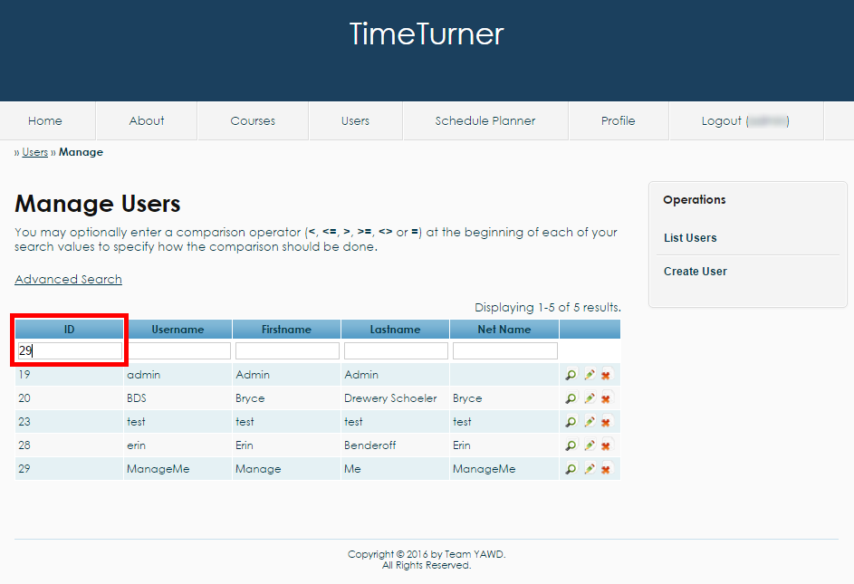

*Figure 4 Entering the desired search criteria in the corresponding textbox*

Once the field completed, the administrator can press ‘enter’ or simply click outside of the textbox to refresh the search table. As a result, the user with the matching ID will be displayed on the table (see Figure 5). If no users have been found to match the search criteria, the table of users will be replaced with a message indicating that no results have been found.

Note that many criteria can be entered in the various textboxes. In such case, the table will reload every time a textbox is out of focus or the key ‘enter’ is pressed. Also, comparison operators can be used in those textboxes, for example to filter all users having an ID less than 30.

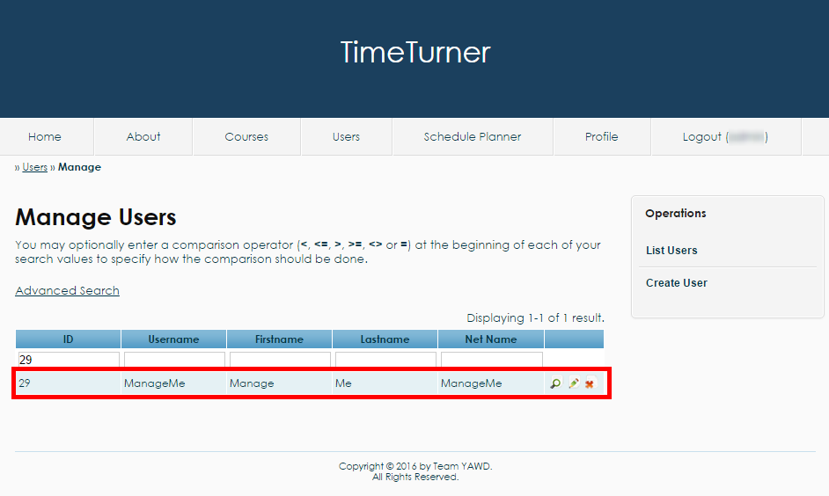

*Figure 5 Result of the simple search by ID*

***Advanced Search for Users***

An administrator may decide to perform an advanced search if many criteria are to be used in the search, and the administrator does not wish the table to constantly refresh while different values for the search criteria are being entered. To do so, the administrator needs to click on the ‘Advanced Search’ link (see Figure 6).

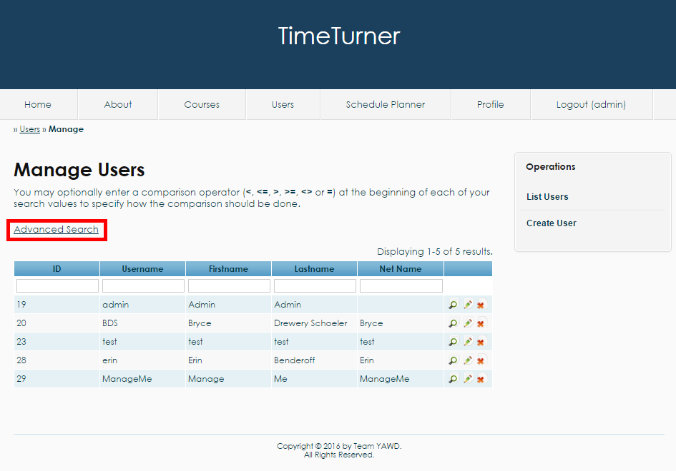

*Figure 6 The ‘Advanced Search’ link*

An advanced search form should appear once the link has been clicked. The form can allow the administrator to look for a user using a combination of multiple criteria by filling up the fields that the administrator wishes to use (see Figure 7).

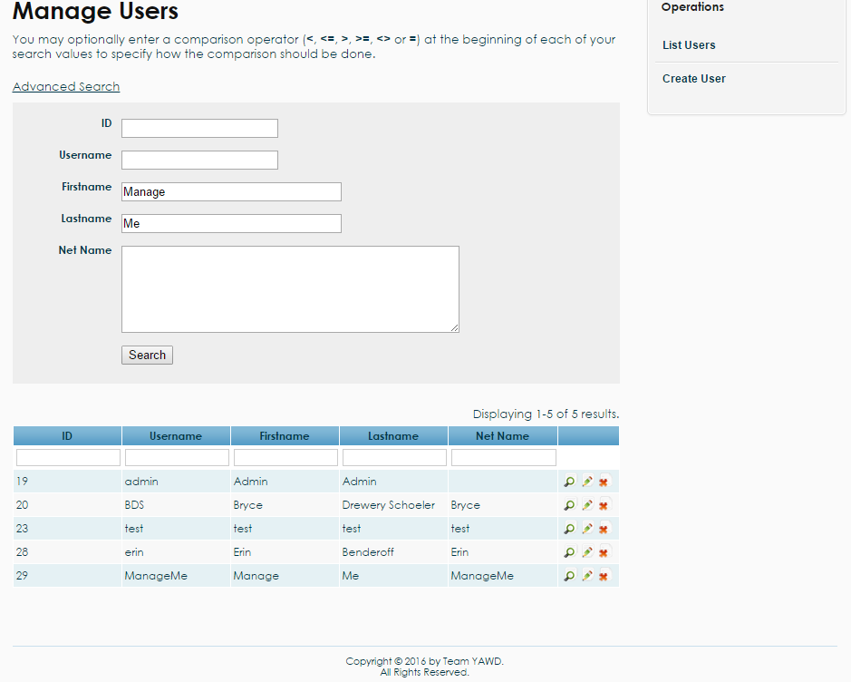

*Figure 7 Usage of the advanced search fields*

Once all the criteria have been decided, the administrator can hit the ‘search’ button at the bottom of the advanced search form. A table should be loaded with the user(s) that match the criteria (see Figure 8). Notice also that the search criteria have been copied into the textboxes for the simple search for clarity.

Like the simple search, the advanced search textboxes support comparison operators and will also display a message that no results have been found if the system fails to find a user based on the specified criteria.

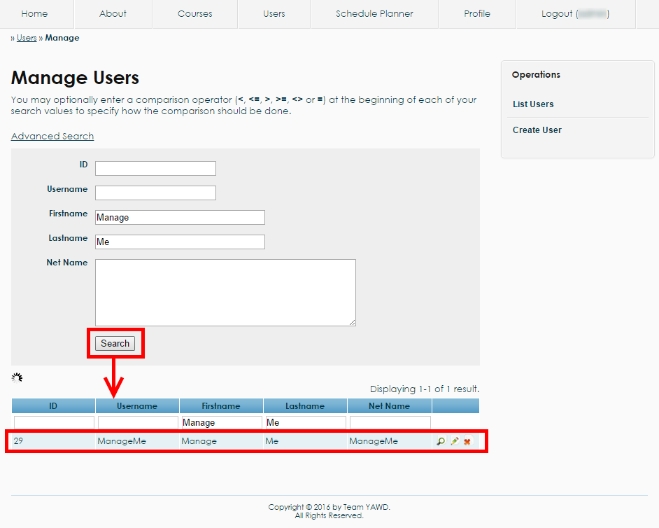

*Figure 8 Post-advanced search results*

***View User***

Whenever a table of users is displayed, either the default one or one that is displayed after a search result, the administrator may decide to view the profile of a user. To consult the profile of a user, the administrator needs to click on the magnifying glass found on the right of row corresponding to the user (see Figure 9).

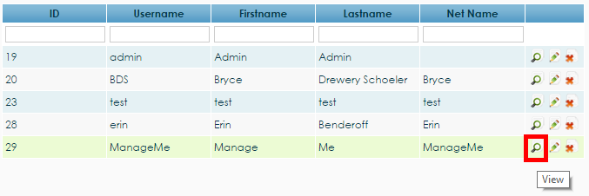

*Figure 9 The view magnifying glass corresponding to the user 29 allowing administrators to consult the profile of this user*

Once the magnifying glass clicked, the profile of the user should be displayed among with a list of available operations that will be discussed in the following sections (see Figure 10).

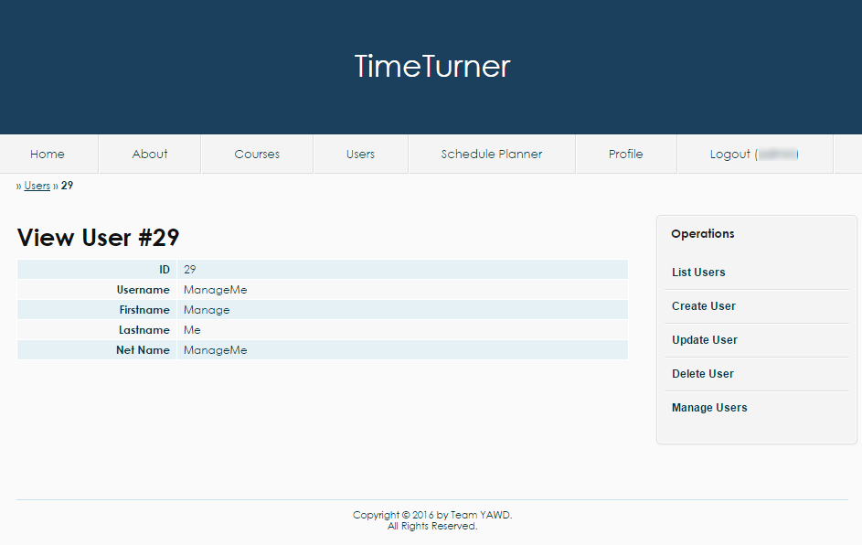

*Figure 10 The profile of a user with a set of operations on the right*

***Update User***

Users’ information can be updated through the user management page. More precisely, updating users’ information can be either be done through the table of users, or through consulting the profile of a user.

To update a user’s information through the table of users, the pencil button found on the right of the row corresponding to the user to be updated should be clicked (see Figure 11).

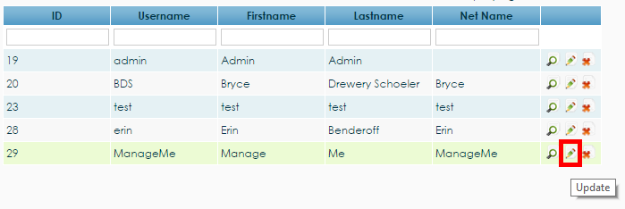

*Figure 11 Pencil button to update the user 29*

To update a user’s information through the user’s profile view, the administrator needs to choose the ‘Update User’ operation from the list of operations found on the left of the page (see Figure 12).

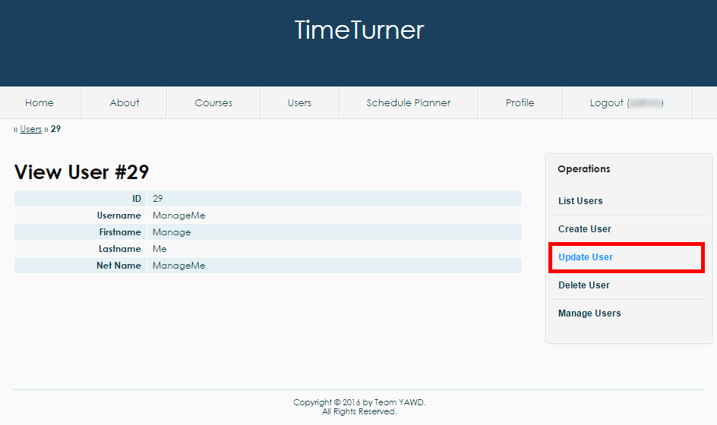

*Figure 12 The operation ‘Update User’ found on the user’s profile page view by an administrator*

From either method, the ‘Update User’ page should now be displayed. The page contains a form which fields are completed with the user’s current information. The administrator can decide to change any of those field and save the changes by clicking the ‘Save’ button (see Figure 13).

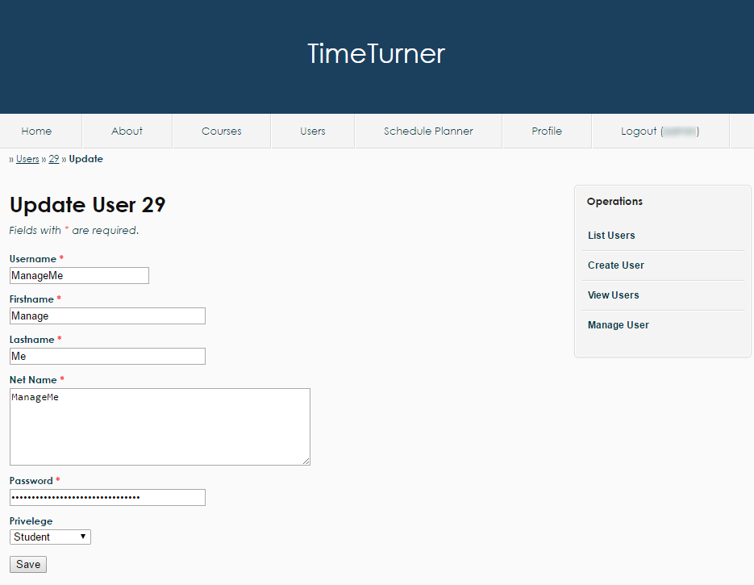

*Figure 13 The ‘Update User’ page having fields that contain the user’s initial information and that can be modified by the administrator once the ‘Save’ button has been clicked*

Once the save button has been clicked, the updated profile of the user should be displayed. Otherwise, some conditions about the fields might have been violated and the administrator needs to correct those violation before updating the user.

***Delete User***

The administrator also has the power to delete a user through the user management page. Once again, deleting a user can be done either through the table of users or through the profile of the user.

To delete a user using the table of users, the administrator should click the ‘X’ button found on the same row as the user to be deleted (see Figure 14).

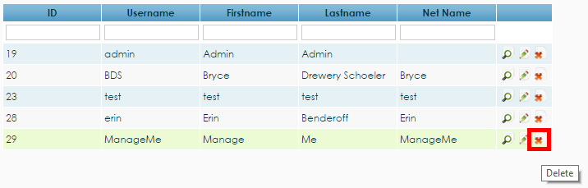

*Figure 14 The ‘X’ button to delete user 29*

To delete a user through the user’s profile page, the operation ‘Delete User’ should be clicked from the list of operations found on the right (see Figure 15).

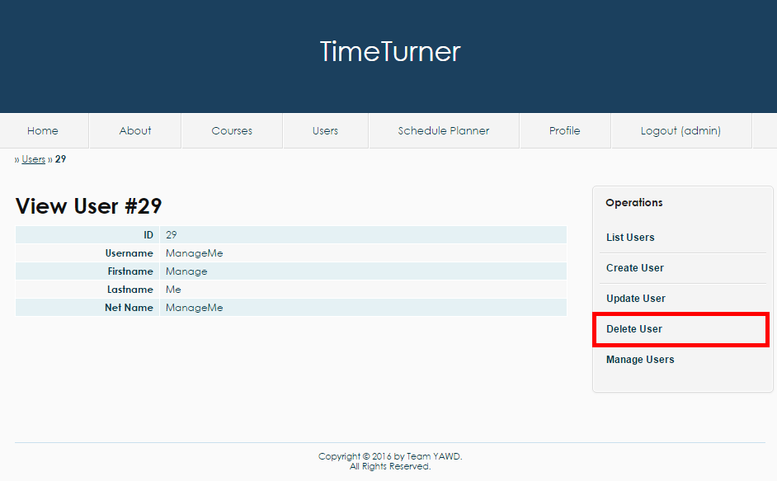

*Figure 15 The operation ‘Delete User’ on the user’s profile page viewed by an administrator*

When either the ‘X’ button or the ‘Delete User’ operation is clicked, a message should pop up to confirm the administrator’s decision (see Figure 16).

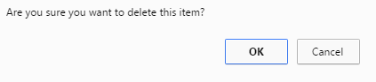

*Figure 16 Confirmation by the system to delete a user*

The administrator should press the ‘OK’ button on the confirmation box to delete the user. Once deleted, the administrator will be brought back to the user management page with an updated table of users.